**Description**

As a user I should be able to create an activity I selected by entering my name and email address.

------------------------------------------------------------------------------------------------------------------------------------------

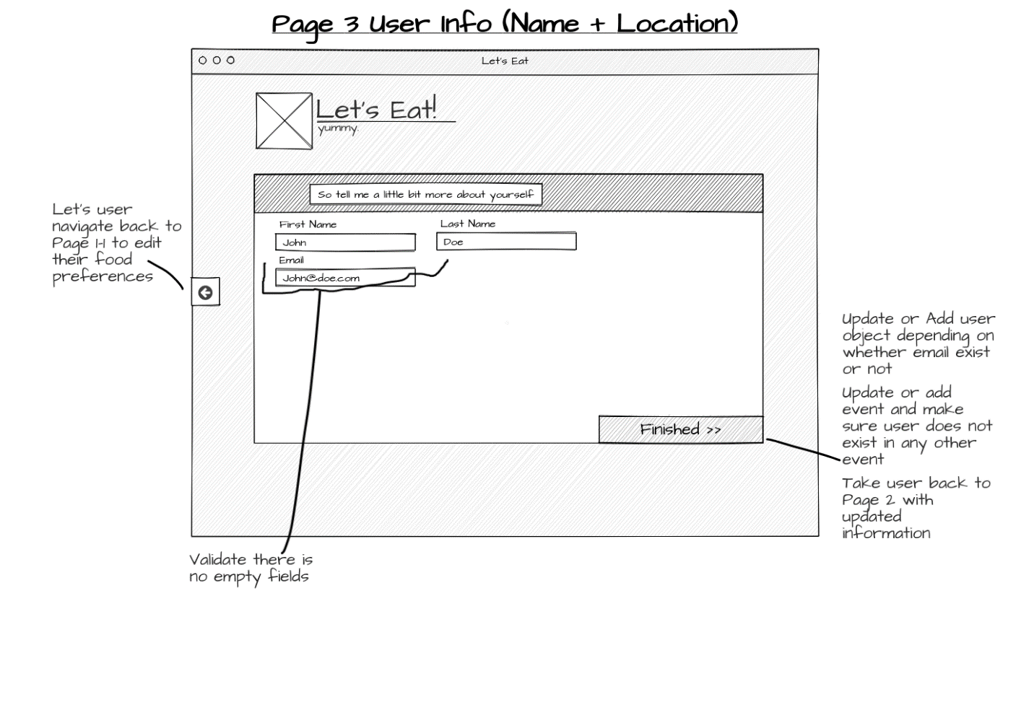

**Acceptance criteria**

* First name & last names are not empty.
* Email address is not empty and is in valid email format.
* Should display button “Finished”
* When “Finished” is clicked it should update the user info in Firebase database.
* If user already exists it should just update or else add new user to the database.
* Add the selected event to the database with timestamp.
* Page should redirect to Activity List with updated user information.